
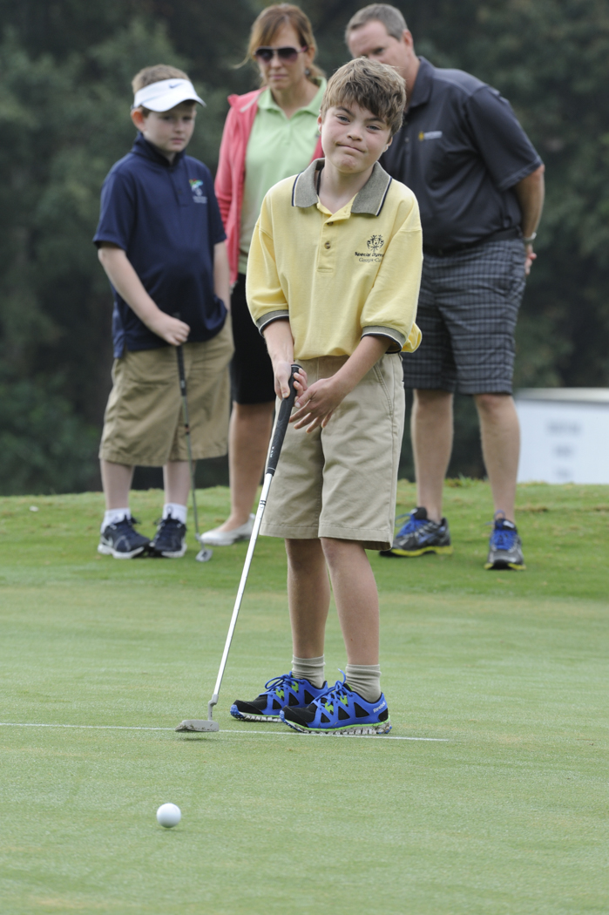
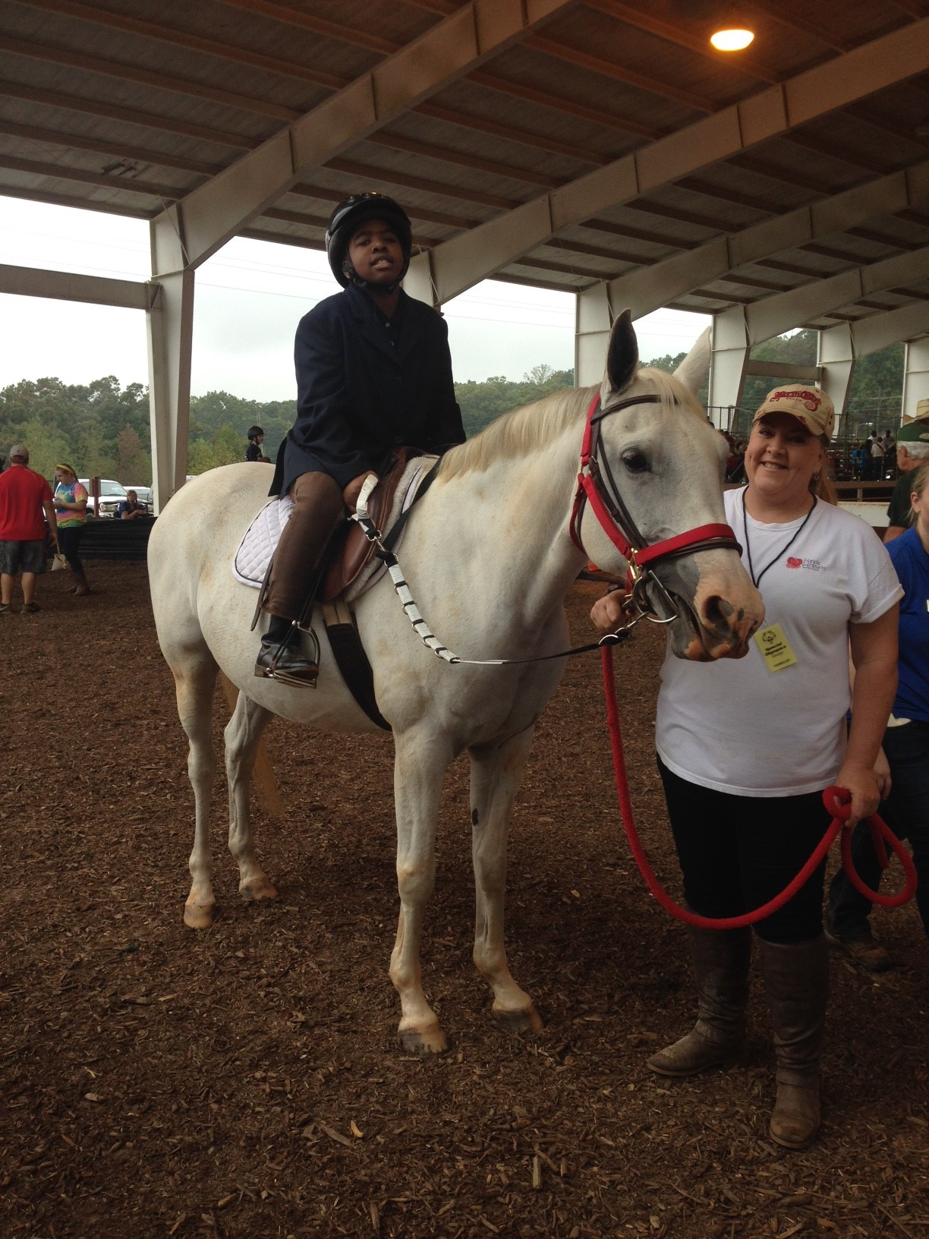
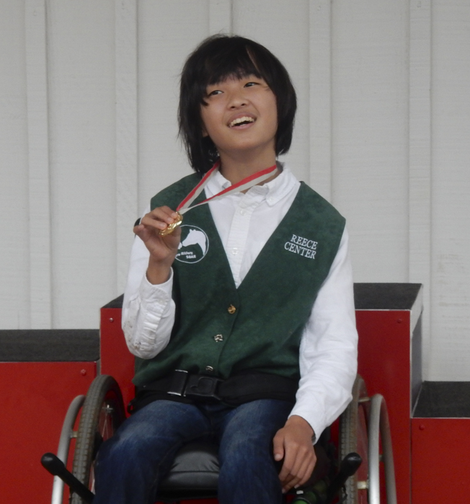
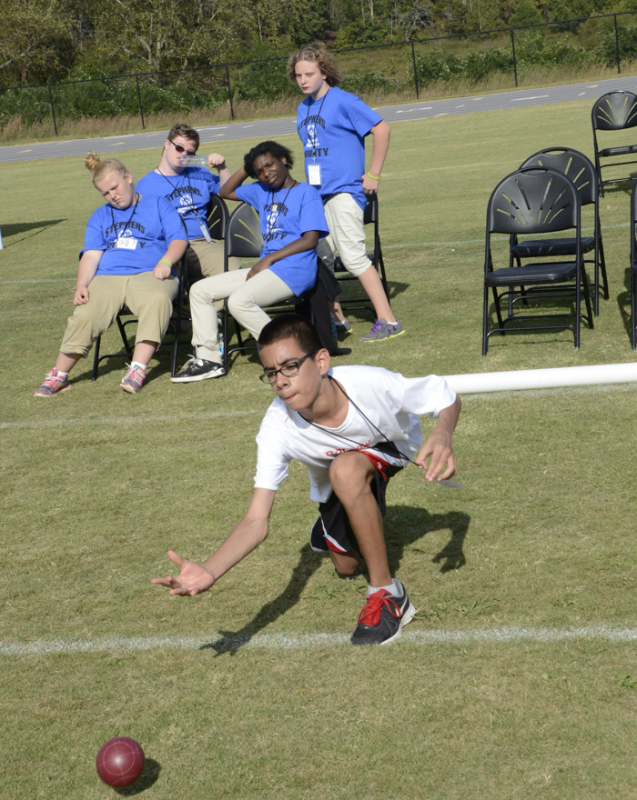
Be a Fan of Special Olympics Georgia in Gainesville!

2017 State Fall Games and State Horse Show
October 13 —15, 2017

Who:
1,600 Athletes
500 Coaches
300 Unified Partners
1,200 Volunteers
Countless Family and Friends!

Where:
North Hall Park
Laurel Park
Chicopee Woods Golf Course
Chicopee Woods Agricultural Center

Sports:
Bocce
Cycling
Equestrian
Golf
Softball

For Horse Show Information:

Sponsorships
Meghan Daves
770-414-9390 ext. 117
meghan.daves@specialolympicsga.org

Volunteers
Paul McNeil
770-414-9390 ext. 116
paul.mcneil@specialolympicsga.org

Events
Kelli Britt
770-414-9390 ext. 122
kelli.britt@specialolympicsga.org

For Fall Games Information:

Sponsorships
Thomas Ritch
770-414-9390 ext. 121
thomas.ritch@specialolympicsga.org

Volunteers
Paul McNeil
770-414-9390 ext. 116
paul.mcneil@specialolympicsga.org

Events
David Crawford
229-292-5143
david.crawford@specialolympicsga.org

