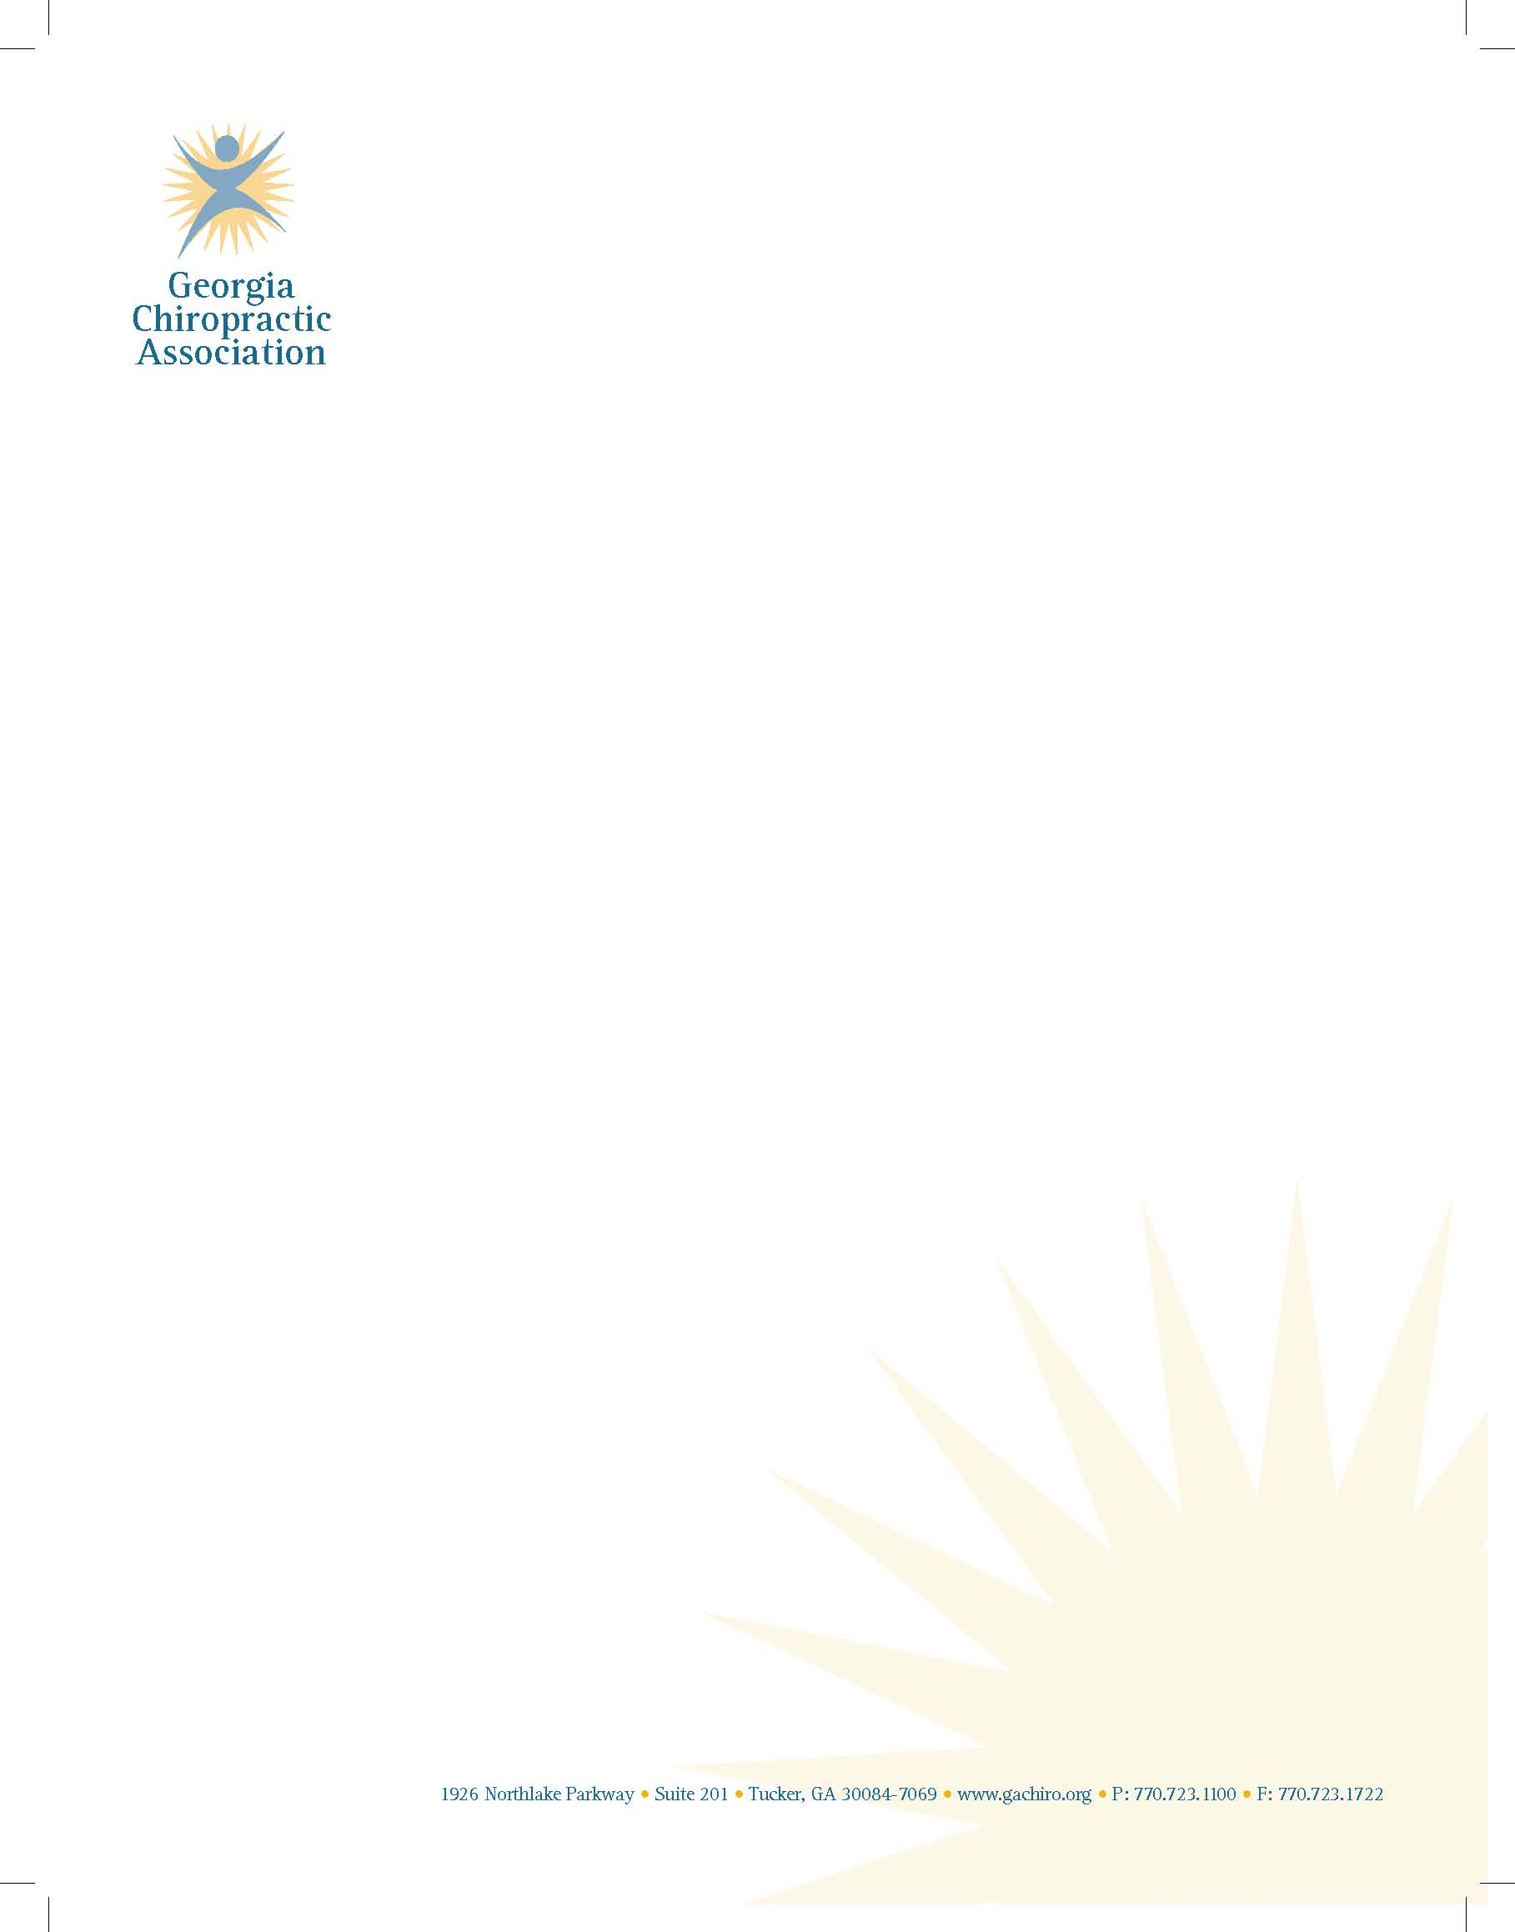

November 10, 2015

Ms. Georgia Milton-Sheats

Special Olympics Georgia

4000 Dekalb Technology Parkway,

Building 400, Suite 400

Atlanta, GA 30340

RE: Special Olympics Georgia

Dear Georgia,

On behalf of the Georgia Chiropractic Association, it is my pleasure to extend our continued support for the Special Olympics Program. It is an honor to participate in a program that provides opportunities for those with disabilities to be included in sports training and athletic competition. Promotion of physical health, self esteem, development of personal relationships and inter-personal skills can have only positive effects on the participants and the community.

Dr. Tony Nicholas, long-time GCA member and supporter has participated and wished to convey our enthusiastic support:

“Very rarely in life are we given the opportunity to render service and receive a gift in return.  The Special Olympics is a rewarding program for the participants, but more so for those who help with this exceptional event.  The kids are so generous with their smiles, exuberance and obvious excitement.  My colleagues, staff and I are so energized by this day that we are often left with tears of joy and a true appreciation for the wonderful gift of health God has given us.  When they are gone we are left with a sense of wishing we could do more and consider ourselves very fortunate to be involved."

We thank you for the invitation to support the activities of Special Olympics, and you may count on our continued involvement.

All Best Wishes,

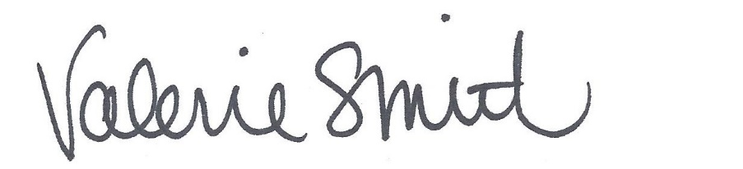

Valerie L. Smith, M.A.

Executive Director