
Join us for an authentic
(all you can eat) Greek Buffet

Benefiting

Friday, April 15, 2011
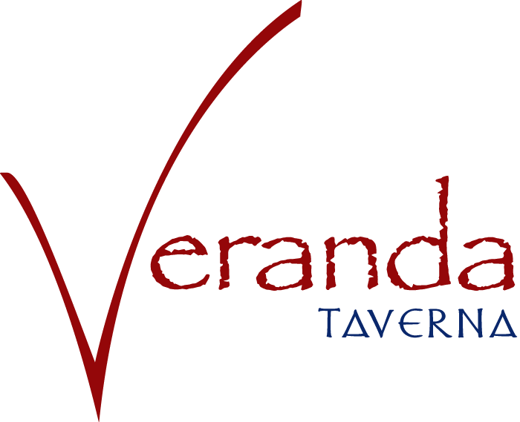
7 p.m. at Veranda Greek Taverna
11235 Alpharetta Hwy, Suite 105 Roswell, GA 30076

$25 ($10 goes to SOGA)
As seen on
America’s Got Talent
And enjoy the sounds of KaZual
9:00 -11:00 p.m.

Dinner includes: Greek Salad, Hummus, Grilled chicken skewers, Pastichio, Gyro meat, Tzatziki sauce, fresh pita bread, and chef’s vegetarian specials. Soft drinks
included

To Register in advance go to:
Click Here

Or Contact Jennifer at
770 414-9390 x 110
www.specialolympicsga.org

www.verandagreektaverna.com

