State Horse Show T-Shirt Pre-Orders
Theme: “Stars, Stripes and Saddles”

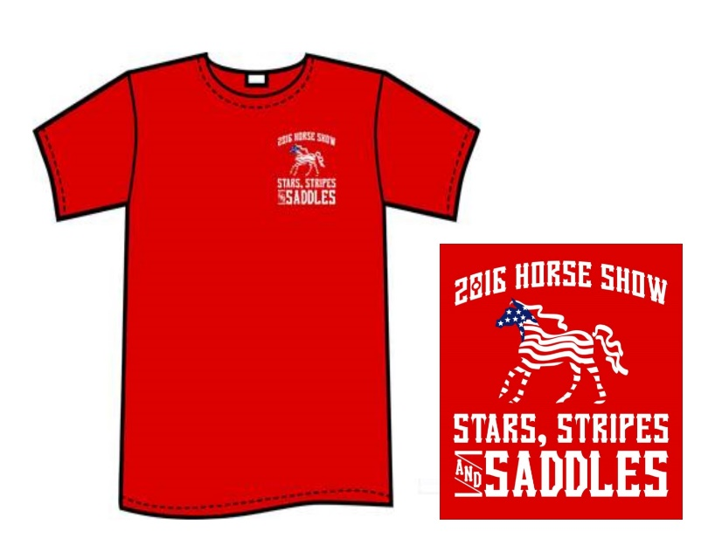

Order Form and Check are due by: September 16th
$15.00 per Shirt (S -2XL)
$18.00 per Shirt (3XL and up)
Please email or fax forms to robert.yost@specialolympicsga.org or Fax (404) 745-0550.
Please make checks out to SOGA and mail to:
Special Olympics Georgia – 4000 DeKalb Technology Parkway, Bld. 400 Ste. 400, Atlanta, GA 30340
SOGA will not mail shirts. They can be picked up at check in on Friday of Games.

Agency: __________________________________________________________________

Contact: __________________________________________________________________

Phone Number: ___________________ E-mail: __________________________________

S _____ 2XL ______

M _____ 3XL ______

L _____ 4XL ______

XL _____ 5XL ______

