State Fall Games T-Shirt Pre-Orders
Theme: “Let’s Play Ball in Hall”

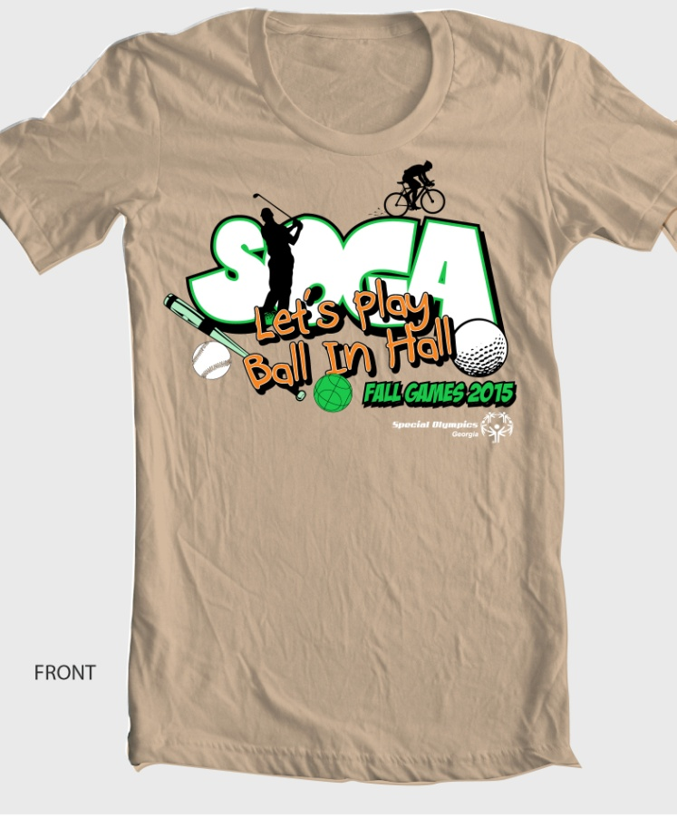

Order Form & Check due by: September 11th
$15 per Shirt (S -2XL)
$18 per shirt (3X)
Please email or fax forms to robert.yost@specialolympicsga.org or Fax (404) 745-0550.
Please make checks out & mailed to:
Special Olympics Georgia – 4000 Dekalb Technology Parkway, Bld. 400 Ste. 400, Atlanta, GA 30340

Agency: ______________________________________________________

Contact: ______________________________________________________

Phone Number: ________________________________________________

S _____ XL ______

M _____ 2XL ______

L _____ 3XL ______

