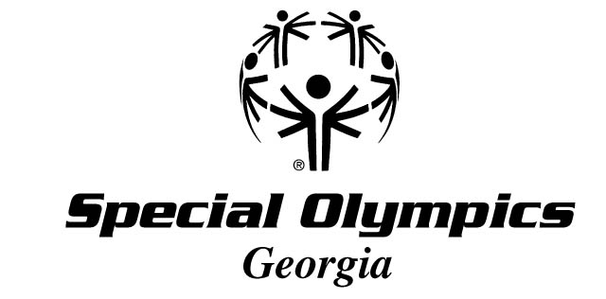

2017 STATE INVITATIONAL SCHEDULE

The following is a schedule of confirmed State Invitationals. Additional Invitationals will be added to this schedule and updates will be available.

SPORT DATE LOCATION SOGA CONTACT
Athletics 3/31/2017 Greater Atlanta Christian, Norcross, GA Devin Dowell
Aquatic 4/8/2017 Columbus Aquatic Center, Columbus, GA Taylor Fulp
Equestrian 5/13/2017 Pegasus Riding Academy, Savannah, GA Liz Smith
Softball 9/16/2017 Central Park, Cumming, GA Kelli Britt
Kayaking 9/23/2017 Henry County Reservoir, Henry County, GA Kelli Britt
For any questions, please contact the assigned SOGA Contact for that Invitational

