Support Special Olympics athletes and
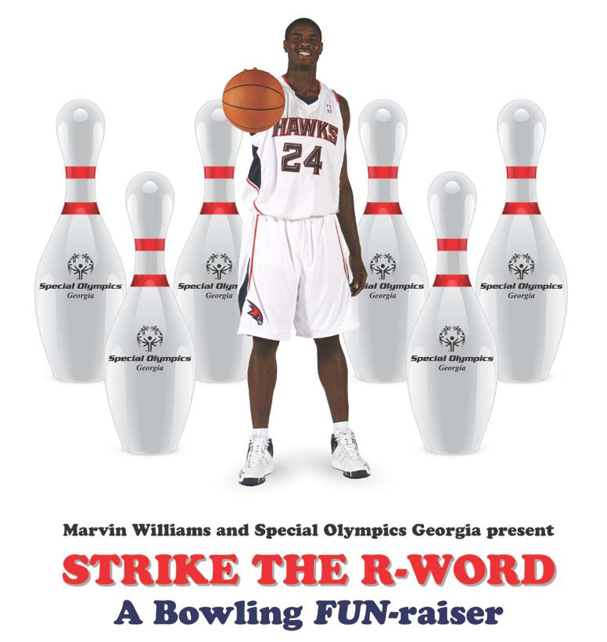



bowl with Marvin Williams!

When: Thursday, September 20 at 6:30 p.m.

Where: 300 Atlanta (2175 Savoy Drive, Atlanta, GA 30341)

Cost: $40 per bowler – includes hors d’oeuvres, drinks, bowling shirts, and great prizes

For more info and to secure your spot, visit www.SpecialOlympicsGA.org then click on “Strike the R-word”

Support Special Olympics athletes and

bowl with Marvin Williams!

When: Thursday, September 22 at 7 p.m.

Where: 300 Atlanta (2175 Savoy Drive, Atlanta, GA 30341)

Cost: $40 per bowler – includes hors d’oeuvres, drinks, bowling shirts, and great prizes

For more info and to secure your spot,
CLICK HERE

