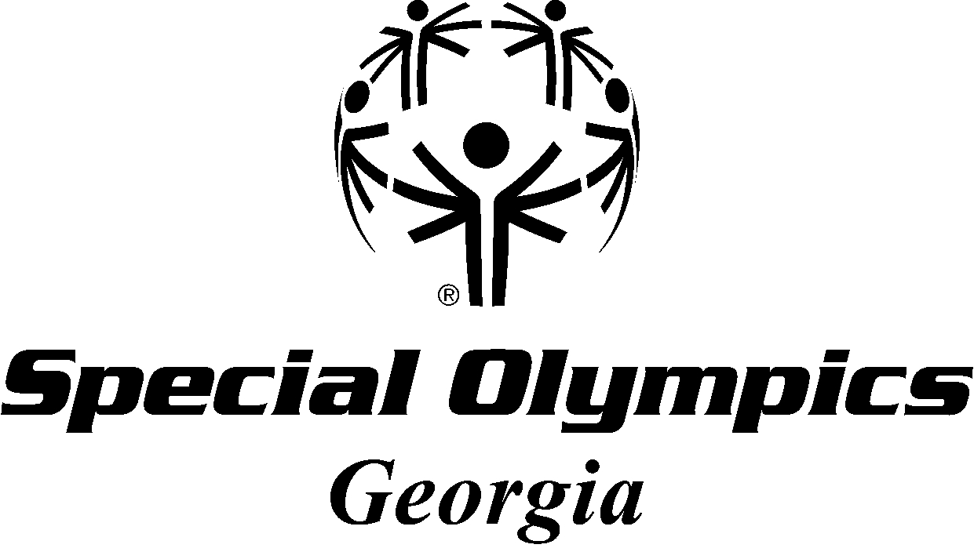
COASTAL GEORGIA MINI-SPORTS CAMP
WHERE: Brunswick, GA
WHEN: May 3rd and 4th
SPORTS: Basketball/Aquatics/Kayaking/Soccer/Volleyball
SCHEDULE: ***Please circle the sessions you plan to attend.***
*Friday, May 3rd 6:00 pm – 9:00 pm General Orientation/Basketball/Unified Sports
*Participants Attend all 3 @ Howard Coffin Park
*Link for Directions to the Howard Coffin Park

*Saturday, May 4th 9:00 am – 12:00 pm Aquatics @ Howard Coffin Park-pool OR
Choose only one for the morning!
Kayaking @ Howard Coffin Pk/SouthEast Adventure Outfitters

12:00 pm – 12:50 pm Lunch Break

1:00 pm – 4:00 pm Soccer @ Howard Coffin Park OR
Choose only one for the afternoon!
Volleyball @ Howard Coffin Park

COST: $25 (Whether you attend one training or all three trainings)
NAME: __________________________________________
AGENCY: __________________________________________
EMAIL: __________________________________________
CELL. # __________________________________________
***Send Mini-Sports Camp Registration and Fees to: SOGA (payable to ‘SOGA’)
***Due date is April 26th *** Attn: Charles White
1601 N. Ashley St. Suite 88
Valdosta GA 31602

Charles White Cell # 229-834-8227 Call in case of cancellation after April 26th or if you can’t locate any of the facilities. Thanks!

