- In your web browser address bar type in: https://registration.specialolympicsga.org/
NOTE: Insure that you use https (not http)

- Enter your GMS Login Id and Password, then click on Connect. If you do not have your Login Id and Password or are having problems connecting please contact your Regional Manager or your Sports Manager.

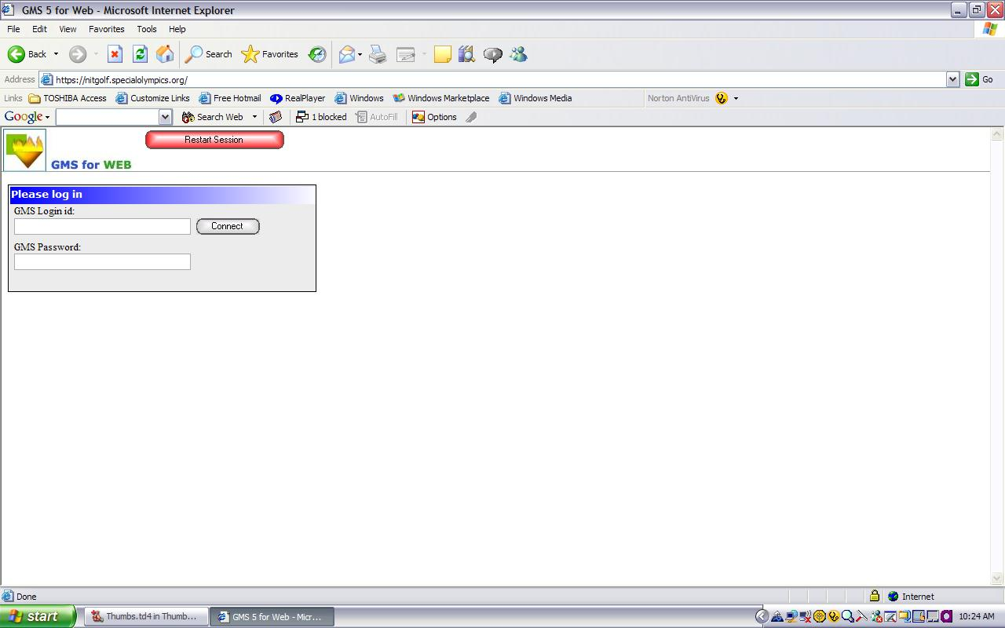
4. Click on Games

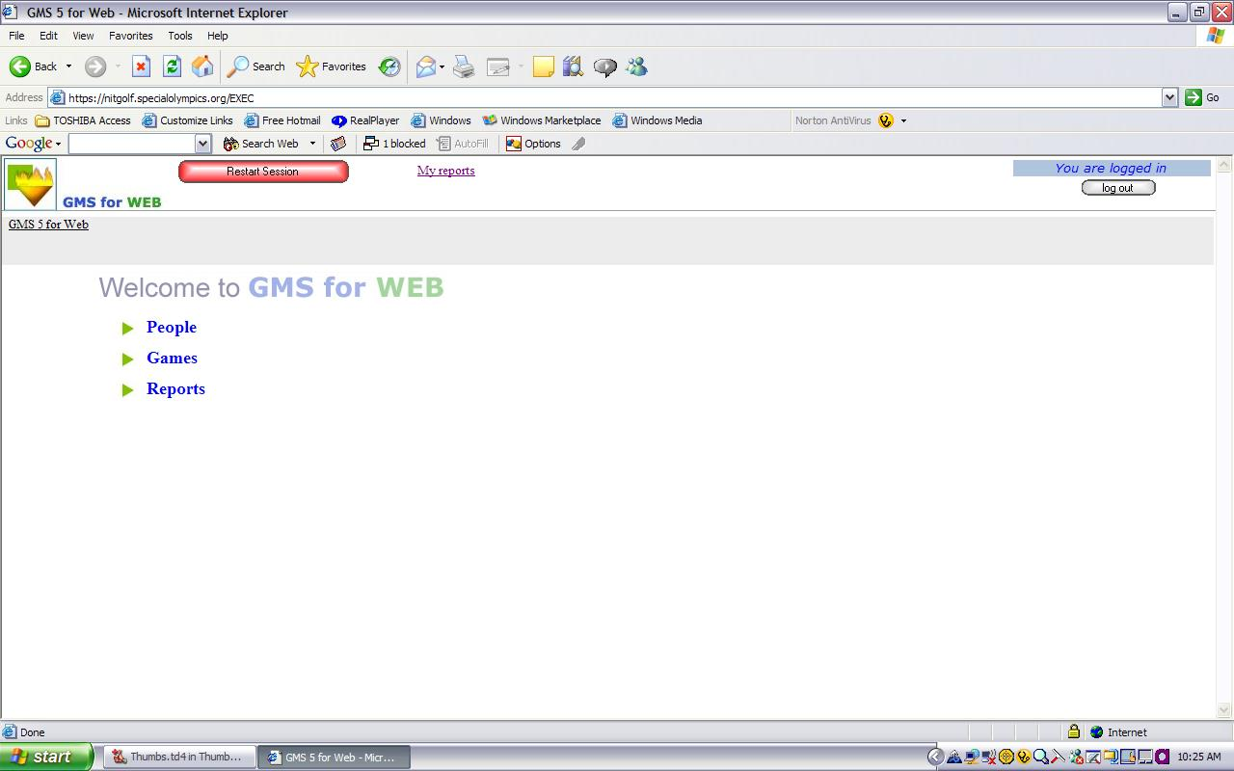

5. From the Games Pull Down, select 2013 Summer Games.

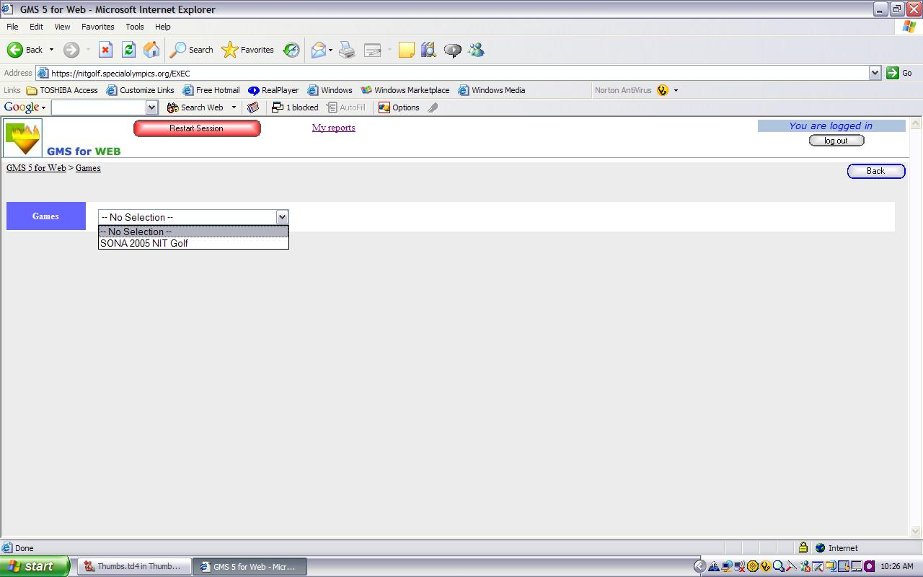
6. Click on the Registration Wizard – (to the right of the Tools button)

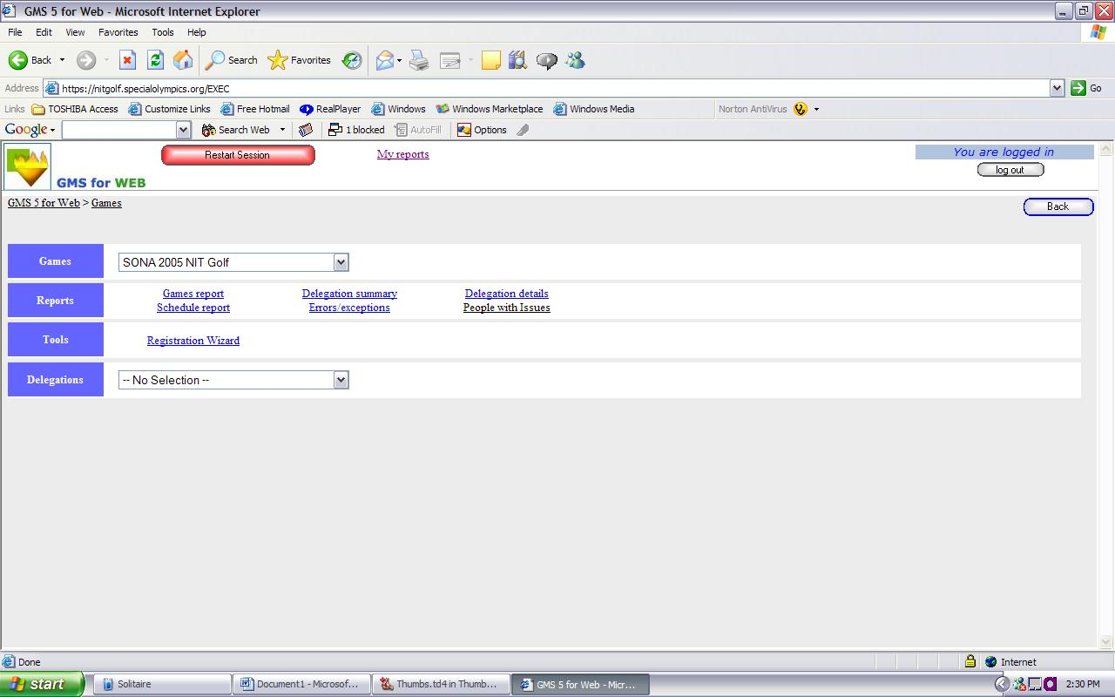

7. This will start the process to register your athletes and coaches for this event, Click Next

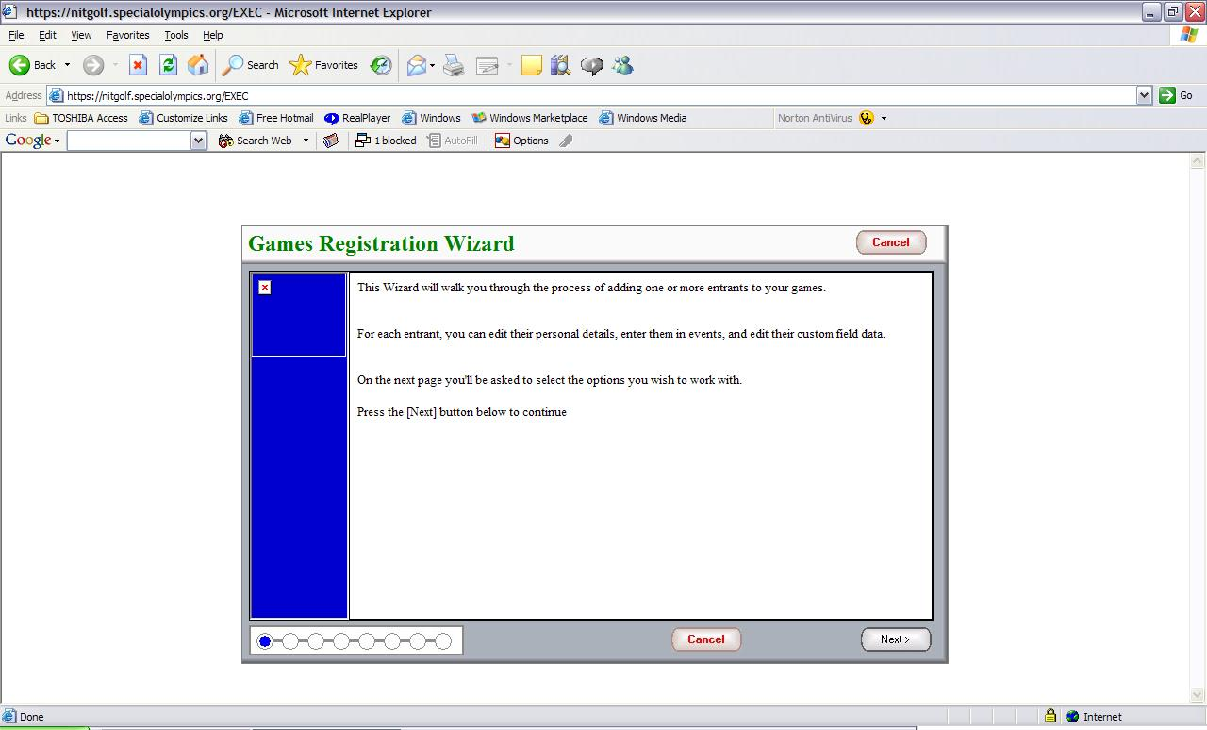
8. Insure that the correct Default entrant role is selected, the default is Athlete. If you need to change this use the pull down menu – you will need to change this when you start entering your coaches and/or unified partners.
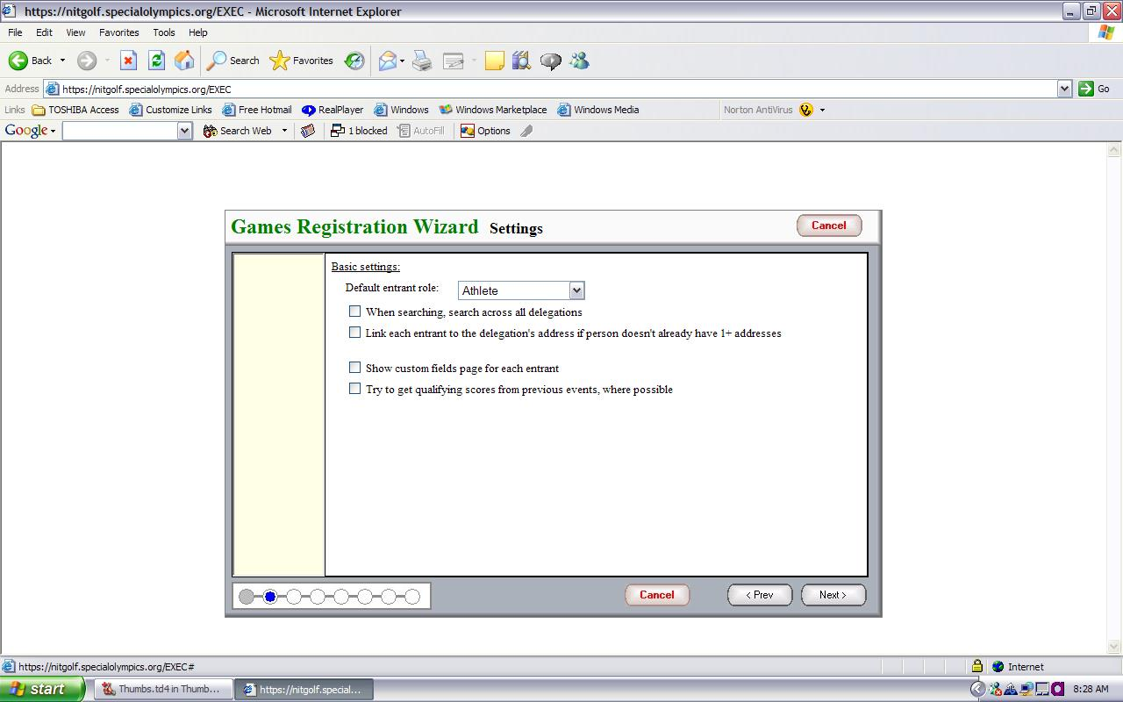

9. By default, the name of your delegation should appear in the “Delegation to put entrant into” (Note; this is set by your login rights) Type in the Last name of the individual you want to register. Click Next
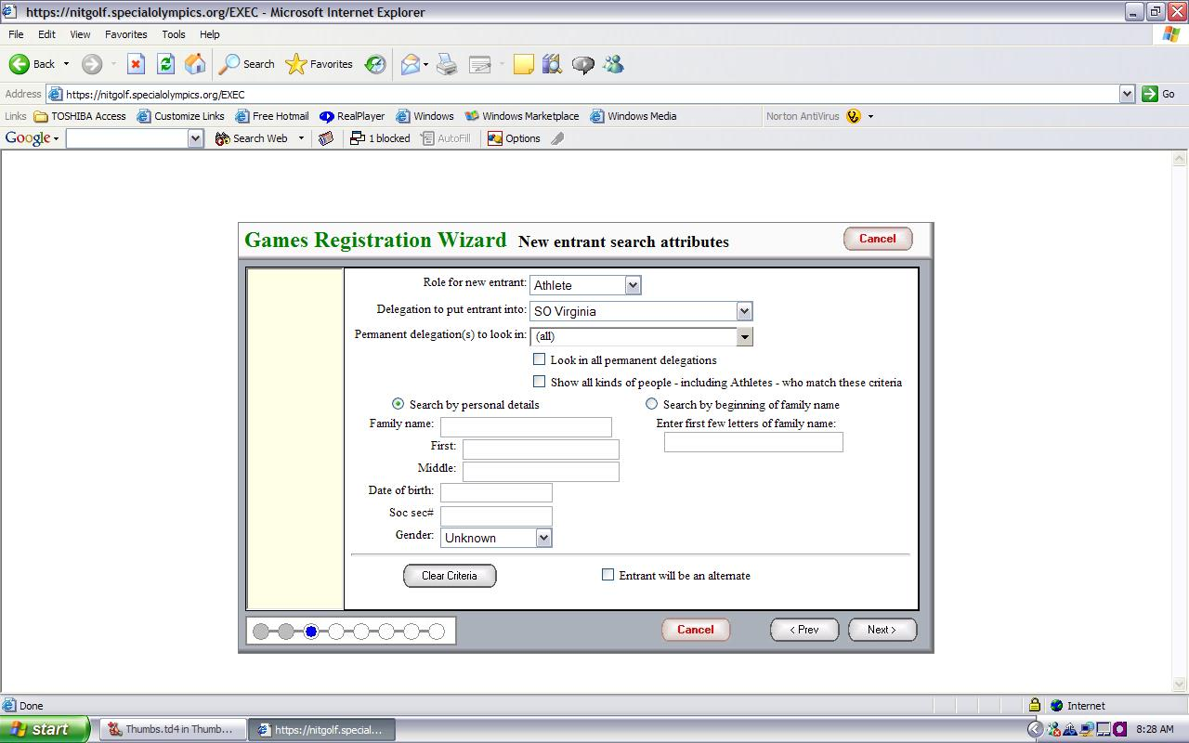

10. Search for your athlete’s name and then select your athlete and click next. On the next screen please select certifications from the drop down menu and ensure that your athlete’s medical form is not expired or will not expire before Summer Games (5/19/2013). Once satisfied click next.
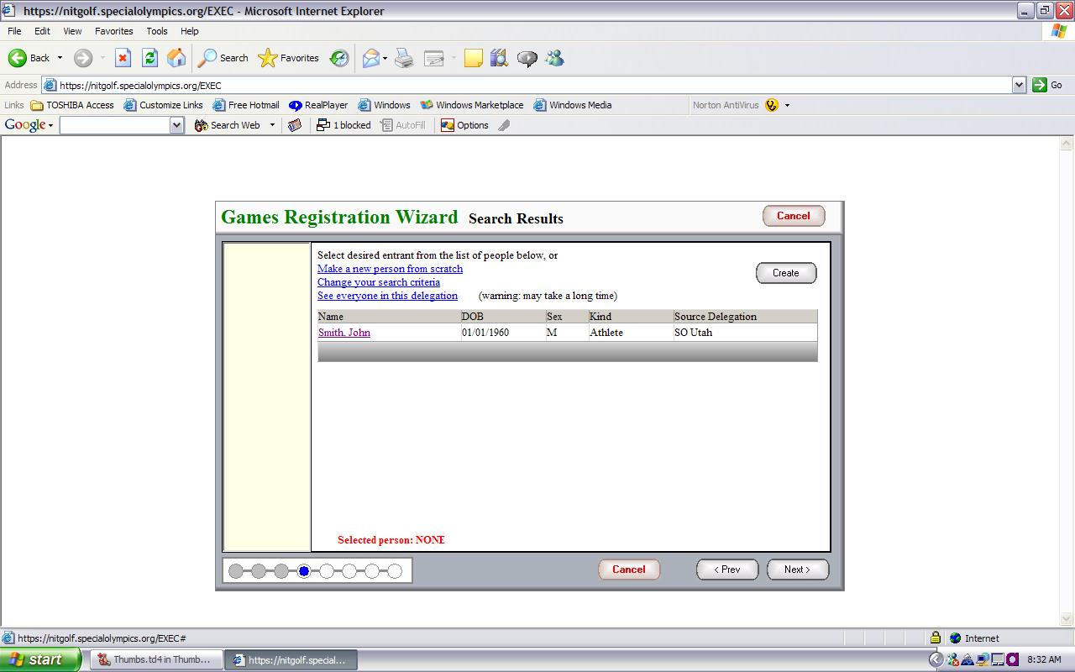

11. Using the Pull Down Menu, Select Entrants Sport
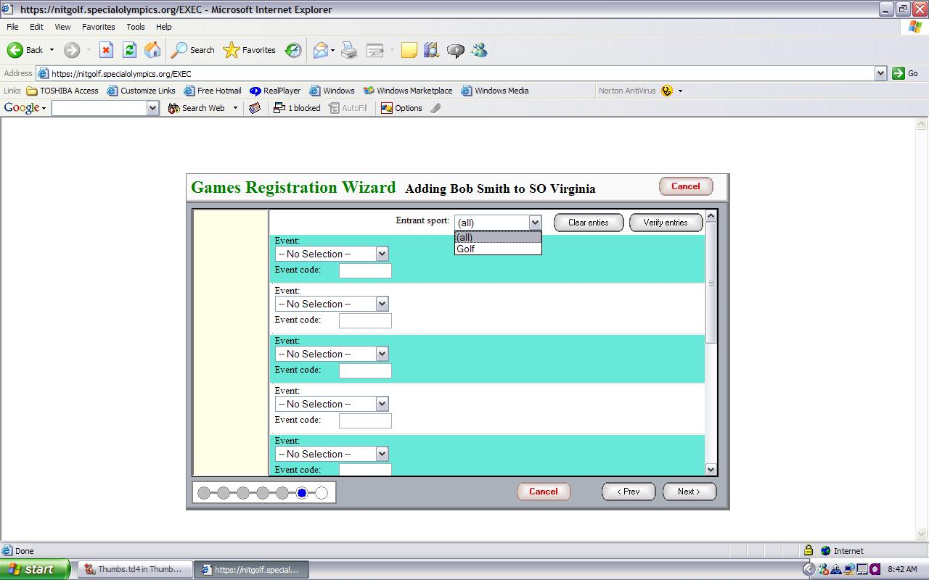

12. On the Event Pull Down, select the Event.

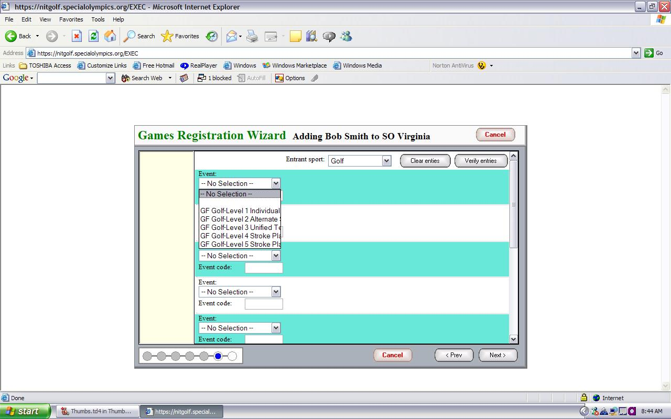

13. Enter the Qualifying Score for those events that require them. If this is a Team Event, follow the directions for #14. For individual events click next after entering all events and scores, and proceed to #17.
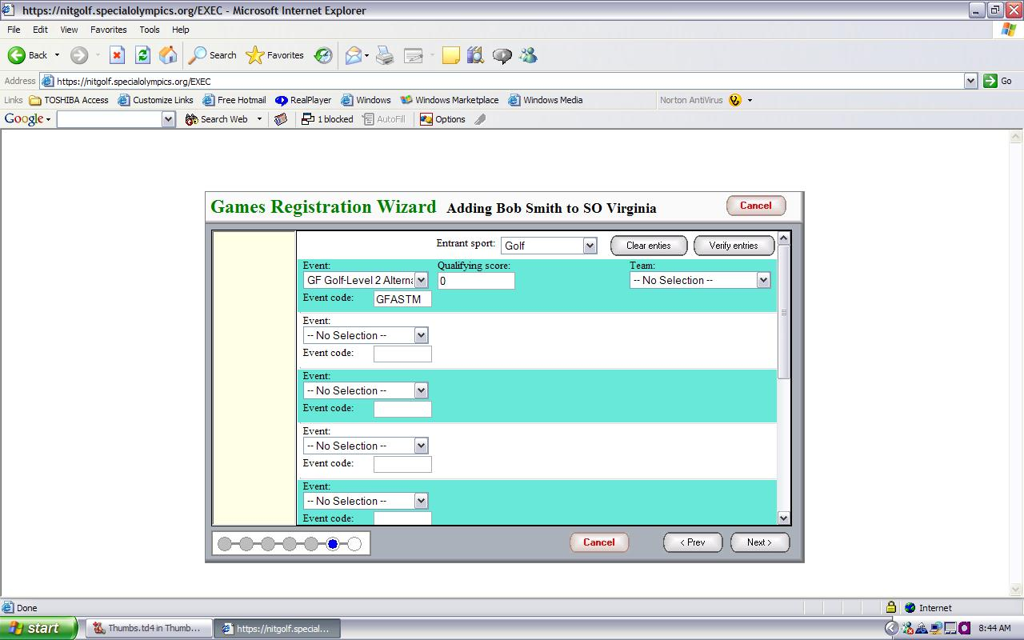

14. If you are entering an athlete into a team such as a unified volleyball team you will need to create the team. You will select the event “Volleyball Unified Team” – Then, using the pull down under Team, click on Define Teams.

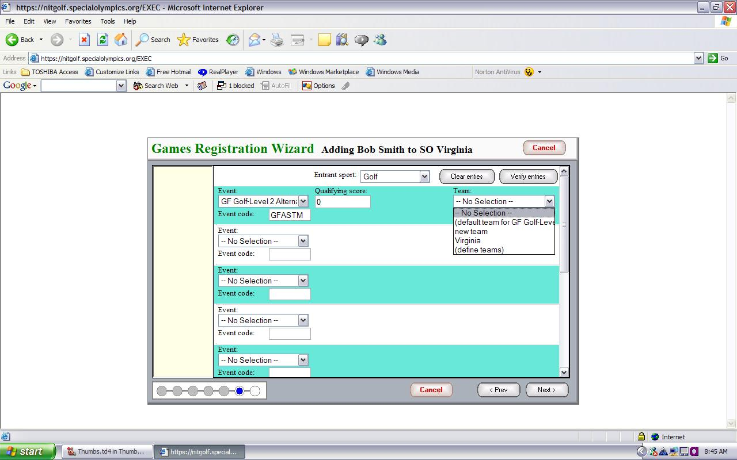

15. To create a Team, click on create a team

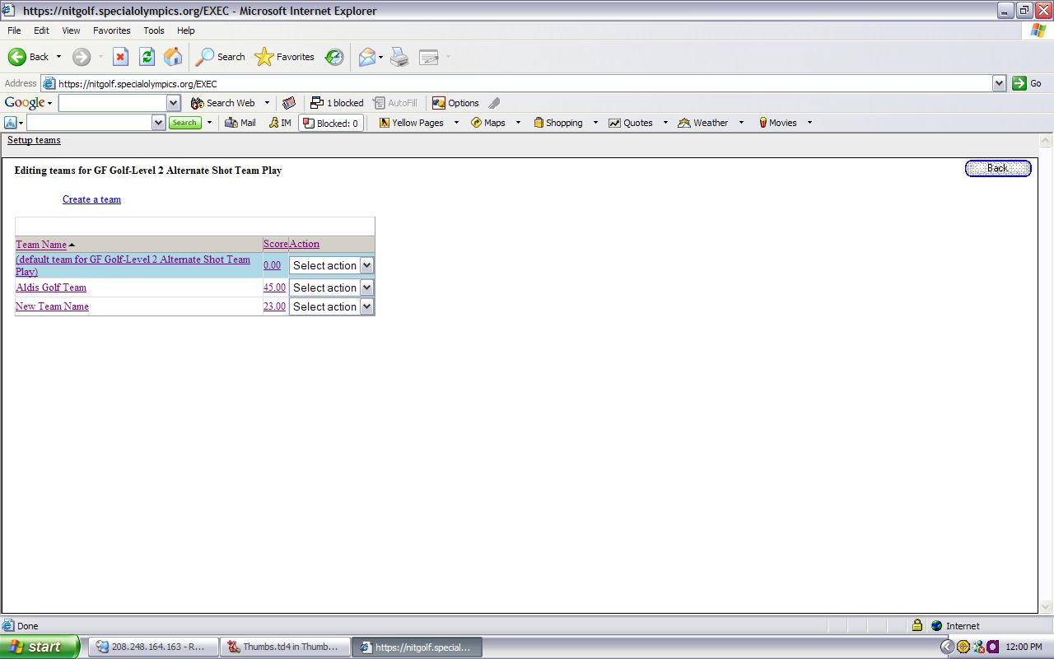

16. Enter the Team Name using this format, the delegation name followed by team name. (for example Fayette All-Stars).
Note: If you have athletes competing in an event with a partner, such as Rhythmic Gymnastics you will also need to create a team name for this partnership. The team name in this instance should follow the format of: the delegation name followed by athlete last name / partner last name. (for example Cobb Smith / Johnson).

Click SAVE Then Click BACK to return to the Events Screen

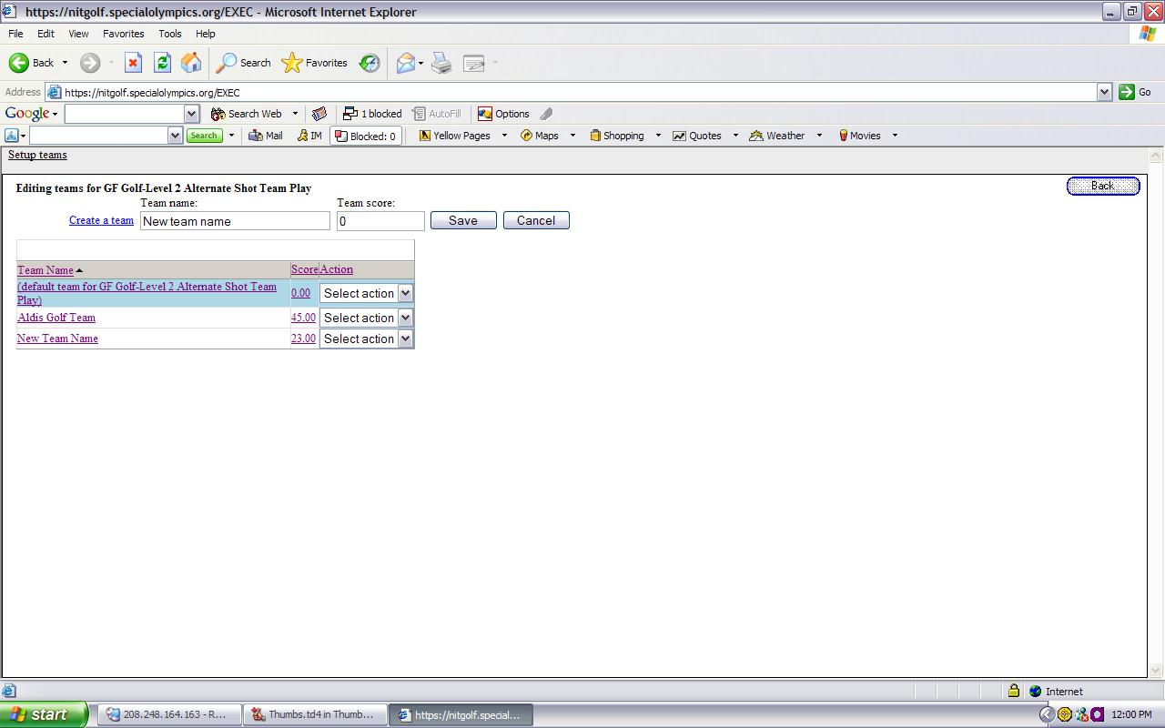

17. This screen will review the registration Process, When you Click Finish, the Registration Wizard will Start Over. If you have entered your last person, uncheck the “Run through the wizard again to add another entrant” box, then Click Finish

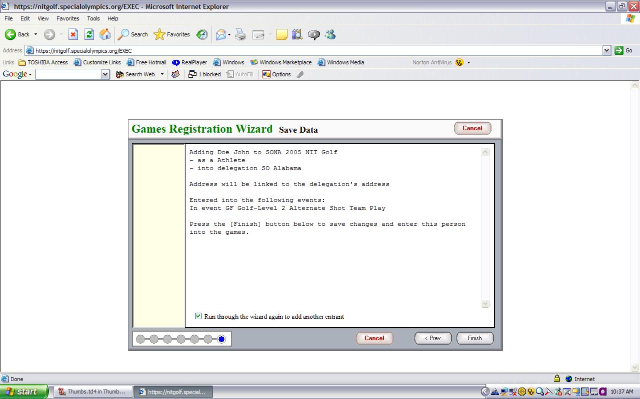

18. You will follow this same process for adding your unified partners and coaches to your roster.

If you have questions please contact your Sports Manager: 770-414-9390

For areas: 1, 2, 3, 4, 6 Kelli Britt, ext. 122

For areas: 7, 8, 11, 17 David Crawford, ext. 103

For areas: 12, 13, 14, 15, 16 Charles White, 229-834-8277

For areas: 5, 9, 10, 18 Max Ellis, ext. 116

