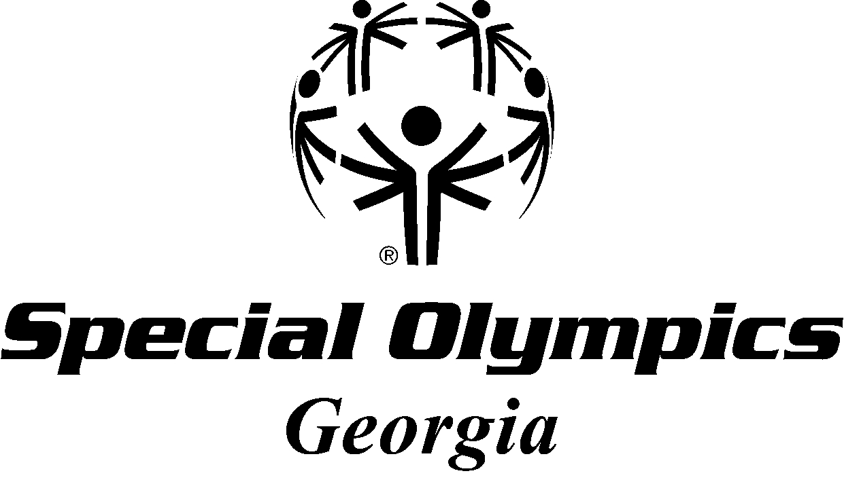
Valdosta Lowndes County Parks and Recreations Authority MINI-SPORTS CAMP 2013

WHERE: Lowndes County GA Valdosta Lowndes Parks and Recreation Authority
1104 West Gordon St. Valdosta GA 31601 (The Craig Center)

WHEN: March 22nd and 23rd 2013

SPORTS: Golf/Bocce/Flag Football/Floor Hockey/Unified Sports/Young Athletes/Equestrian
SCHEDULE:
Friday 3/22 4:30 pm – 7:00 pm General Orientation / Golf/GMS
Saturday 3/23 10:00 am – 12:30 Equestrian/Flag Football/Unified Sports

12:30 – 1:15 Lunch

1:30 – 4:00 Young Athletes/Bocce/Floor Hockey

COST: $25 (Whether you attend one training or multiple trainings)
NAME: __________________________________________
AGENCY: __________________________________________
EMAIL: __________________________________________
CELL. # __________________________________________
***Send Mini-Sports Camp Registration and Fees to: SOGA (payable to ‘SOGA’)
***Due date is March 15th *** Attn: Charles White
1601 N. Ashley St. Suite 88 Valdosta GA 31605

