Media Alert - Macon
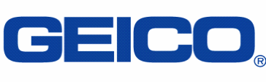

GEICO Road Race raises $59,000 for Special Olympics Georgia

Check presentation set for May 1st

Who: GEICO, Area 7 Special Olympics and Special Olympics Georgia

What: In March, hundreds of Macon-area runners participated in the 30th Annual GEICO 5k Road Race to raise money for Special Olympics Georgia. As a result, GEICO will be presenting a check to Special Olympics Georgia in the amount of $59,150.

Where: GEICO’s Macon Office
4295 Ocmulgee East Blvd.
Macon, GA 31295

Take Exit #6 on I-16; follow signs to the building on the left side of the road.

(The presentation will be taking place in Building #2’s cafeteria)

When: Wednesday, May 1, 2013
10:30 a.m.

For more information, contact:

Randy Thompson
rathompson@geico.com
478-744-4139

