T-Shirt Pre-Orders

Theme: “Let’s Play Ball in Hall”
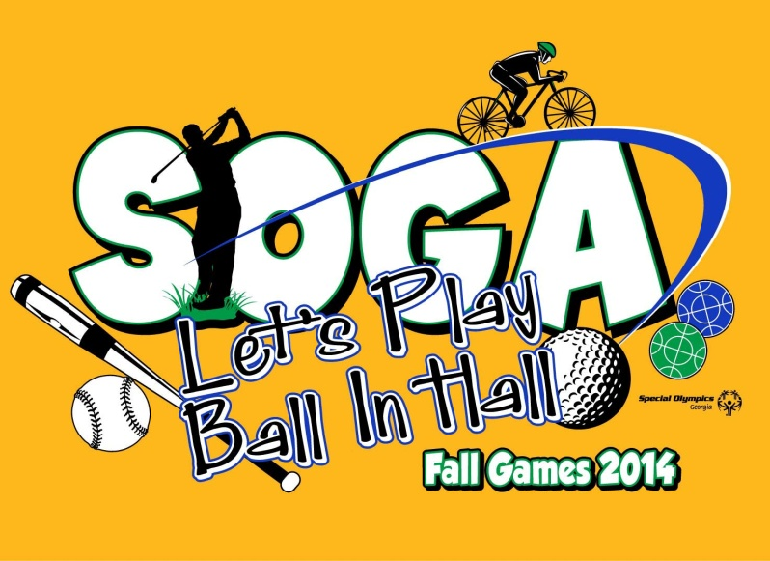

Order Form due to Stephen Sparks on: September 23rd
$15 per Shirt S-XL
$18 per Shirt 2XL-3XL
You may be paying slightly more than at the event in order to guarantee the number of shirts you are requesting!
Please make checks out to:
Special Olympics Georgia

Please mail to:
1601 N Ashley St, Ste. 88
Valdosta, GA 31602

Agency: ______________________________________________________

Contact: ______________________________________________________

Phone Number: ________________________________________________

S ________
M ________
L ________
XL ________
2XL _______ ($18)
3XL ________ ($18)

