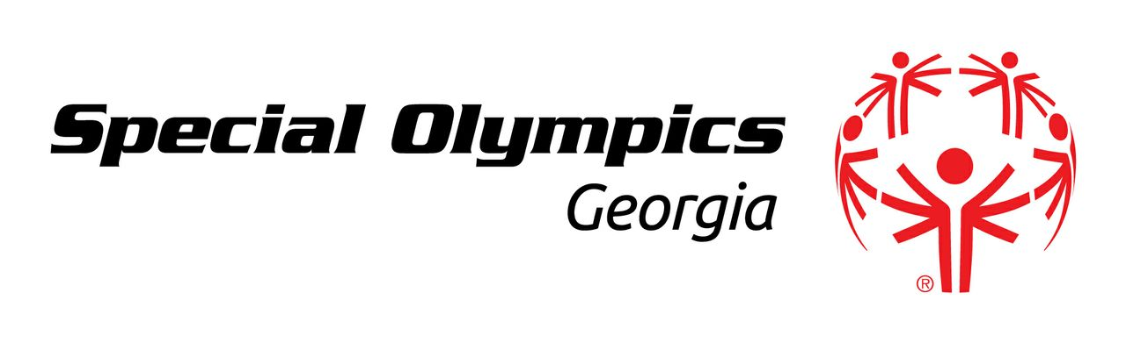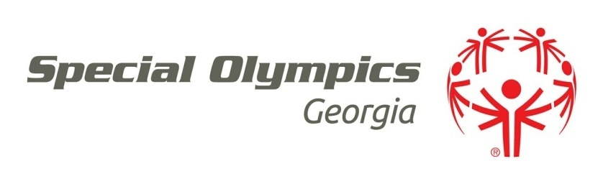

**Saturday, September 15th, 2018**

7:00p.m. – 10:00 p.m.

*The Patterson  
100 North Patterson St.*

*Valdosta, GA 31601*

**Featured will be presentations by Valdosta Special Olympics Athletes   
& live music by local artists.   
The evening will also include a great silent auction,   
drinks & hors d’oeuvres, & a chance to win free prizes!**

*All proceeds will benefit Special Olympics Georgia, which provides year-round sports training   
and athletic competition in a variety of Olympic-type sports for children and adults with intellectual disabilities, giving them continuing opportunities to develop physical fitness,   
demonstrate courage, experience joy and participate in a sharing of gifts, skills and friendship   
with their families, other Special Olympics athletes and the community.*

**Tickets purchased before the event:   
$30 per person or $50 per couple**

Purchased at the door:  
 $35 per person or $60 per couple

To purchase tickets, make a donation, become a sponsor,

or for more information, please contact:

Miranda Moore (229) 712-9973  
[miranda.moore@specialolympicsga.org](mailto:miranda.moore@specialolympicsga.org)