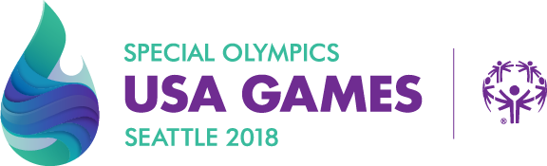

WHAT: 2018 USA Games
WHERE: Seattle, Washington
WHEN: June 30 – July 6, 2018
SPORTS: 14 Sports will be offered
WHO: 3500 Athletes and 1000 Coaches
TEAM GEORGIA:
Traditional Basketball Team – Hall County (10 Athletes, 2 Coaches)
Unified Volleyball Team – Gwinnett County (10 Athletes / Partners, 2 Coaches)
Unified Soccer Team – Special K’s (12 Athletes / Partners, 3 Coaches)
Unified Golf Team – Douglas County (1 Athlete / 1 Partner)

