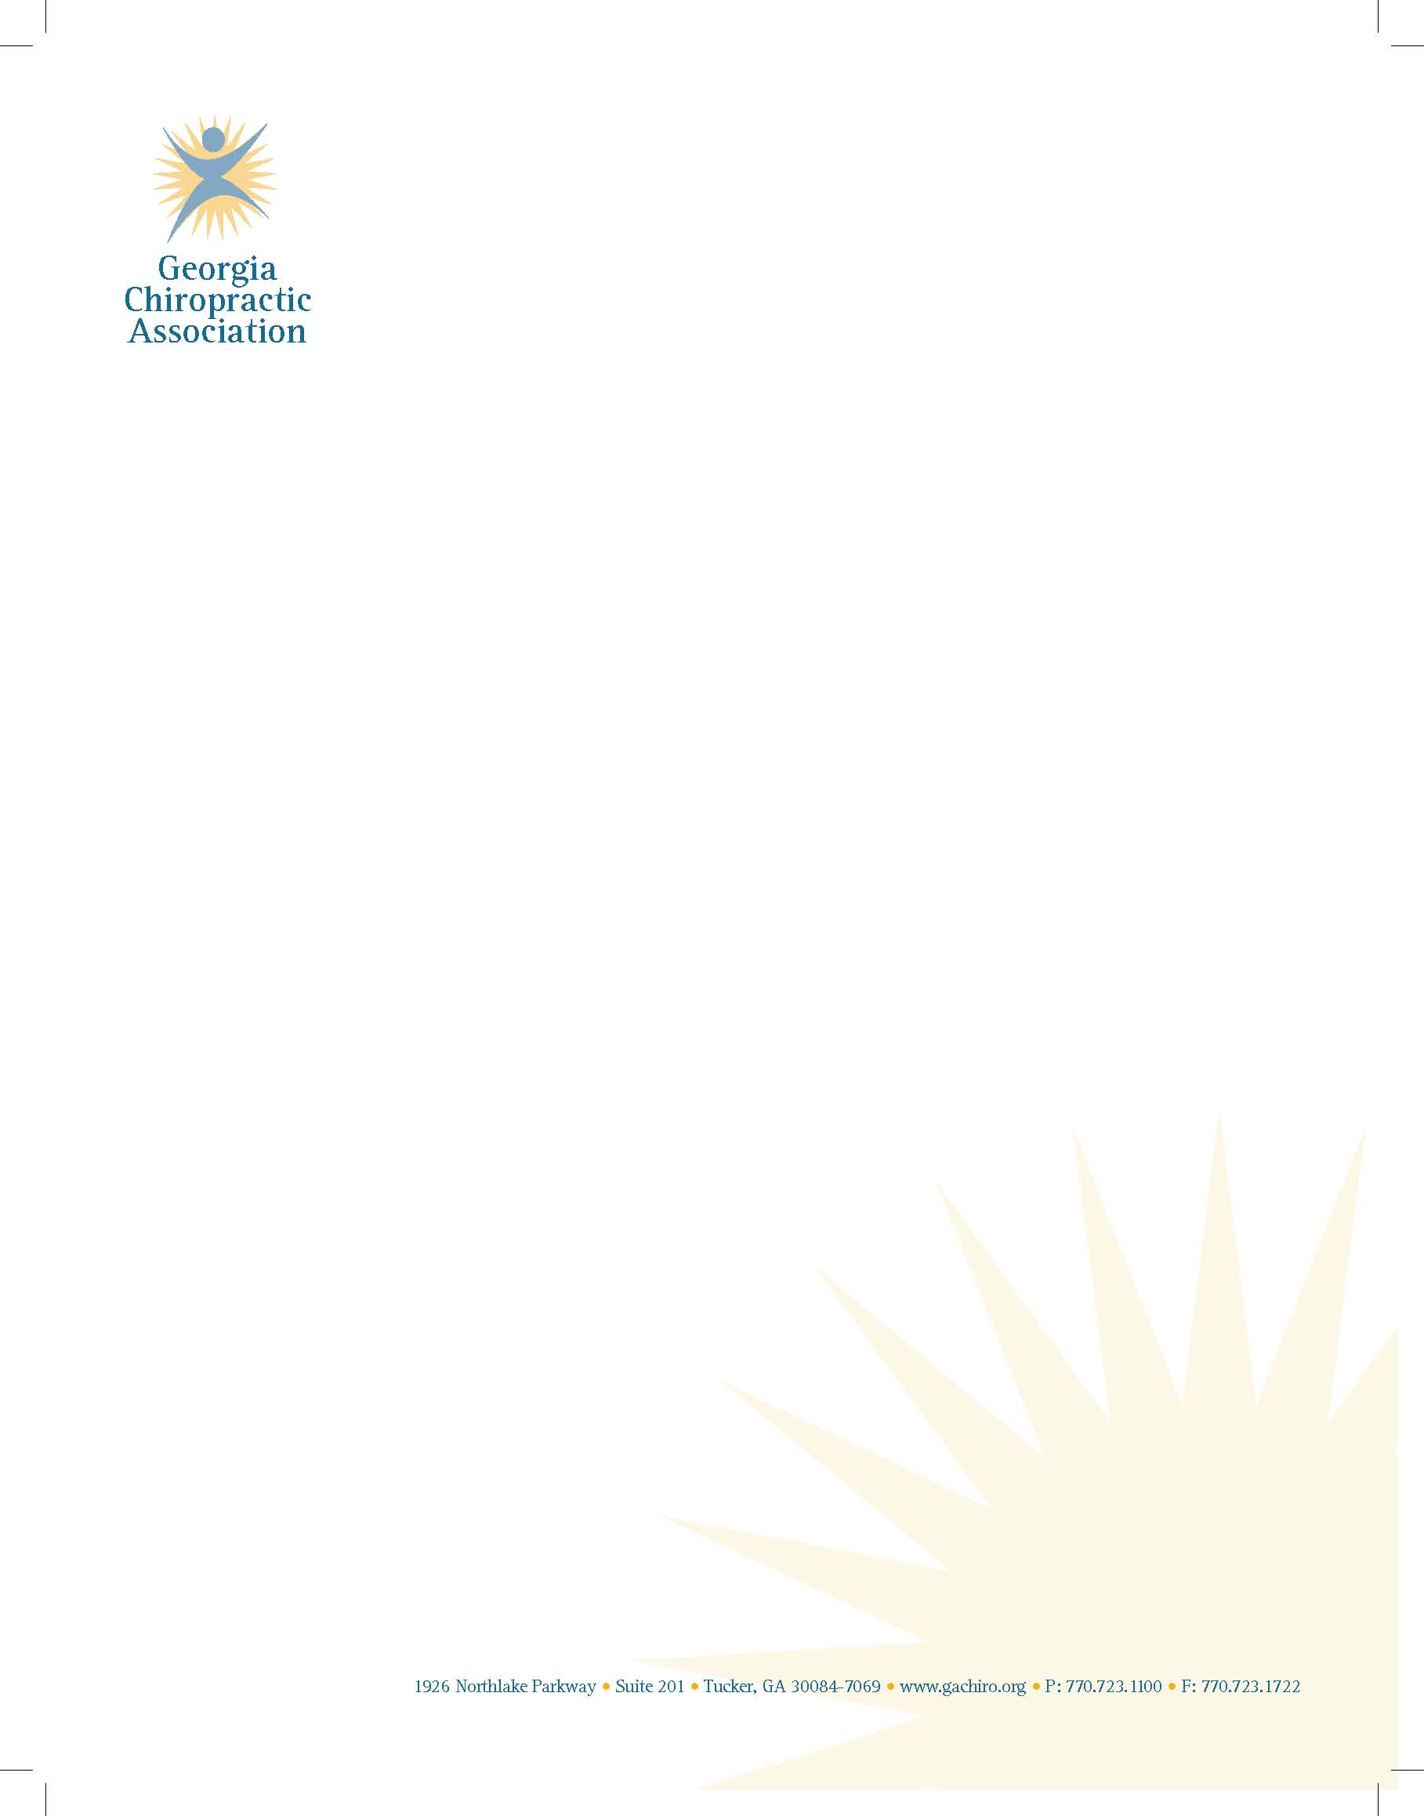

December 15, 2017

Ms. Georgia Milton-Sheats

Special Olympics Georgia

6046 Financial Dr.

Norcross, GA 30071

Dear Georgia,

On behalf of the Georgia Chiropractic Association, it is my pleasure to extend our continued support for the Special Olympics Program. It is an honor to participate in a program that provides opportunities for those with disabilities to be included in sports training and athletic competition. Promotion of physical health, self esteem, development of personal relationships and inter-personal skills can have only positive effects on the participants and the community.

Dr. Tony Nicholas, long-time GCA member and supporter has participated and wished to convey our enthusiastic support:

"Ever since the GCA has been involved with the Special Olympics, my colleagues, staff and I are energized and excited to help with the process.  It is such a fulfilling and rewarding exchange.  We do a "small" service and in exchange we are rewarded by the Special Olympians with generous amounts of smiles, laughs, hugs and unbridled exuberance.  The clinic is bustling with energetic students who seek only to please us. Often we find ourselves wiping a tear of joy that "wells" up in our eye! It becomes abundantly clear to us that these kids are truly a gift from God. It is not uncommon to hear an "I love you." How can you not appreciate the realization of your own God given blessings! You give a little ... you get a lot!"

We thank you for the invitation to support the activities of Special Olympics, and you may count on our continued involvement.

All Best Wishes,

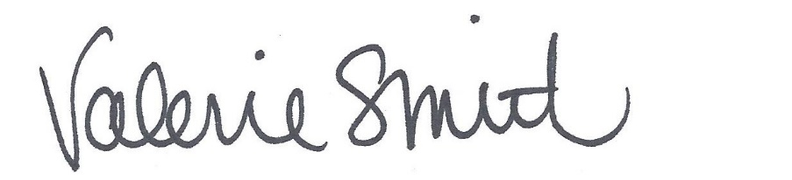

Valerie L. Smith, M.A.

Executive Director