State Masters Bowling T-Shirt Pre-Orders

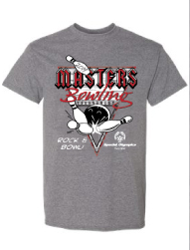

Order Form and payment are due by: July 22, 2019
We do not accept cash payments! CHECK ONLY
Shirts are $20 each.
Please email or fax forms to danielle.hogan@specialolympicsga.org 404-393-2929.
Please make checks out to SOGA and mail to:
Special Olympics Georgia – 6046 Financial Drive, Norcross GA 30071
Attention to: Danielle Hogan
SOGA will not mail shirts. They can be picked up at housing check in on Friday of Games.

Agency Name: __________________________________________________________________

Contact Name: _________________________________________________________________

Phone Number: ___________________ E-mail: _______________________________________

Check yes if you are a registered Volunteer for these Games: YES _______ If yes, your shirt can be picked up at the Volunteer Registration table.

S _____ 2XL ______

M _____ 3XL ______

L _____ 4XL ______

XL _____ 5XL ______

6XL ______

Total number of shirts ordered: __________

Total amount of money owed $__________

