29th Annual

Bob Busse Memorial Golf Classic

Presented By

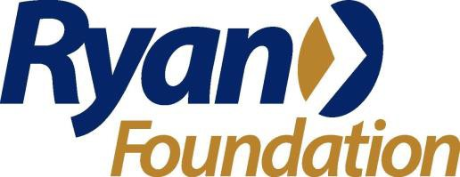

November 11th, 2024

2500 Country Club Drive
Roswell Country Club
Roswell, GA 30076

9:00am

Registration, Breakfast, Warmup
10:00am
Shotgun Start
Our Mission

To provide year-round sports training and athletic competition in a variety of Olympic-type sports for all children and adults with intellectual disabilities, giving them continuing opportunities to develop physical fitness, demonstrate courage, experience joy, and participate in the sharing of gifts, skills and friendship with their families, other Special Olympics athletes, and the community.
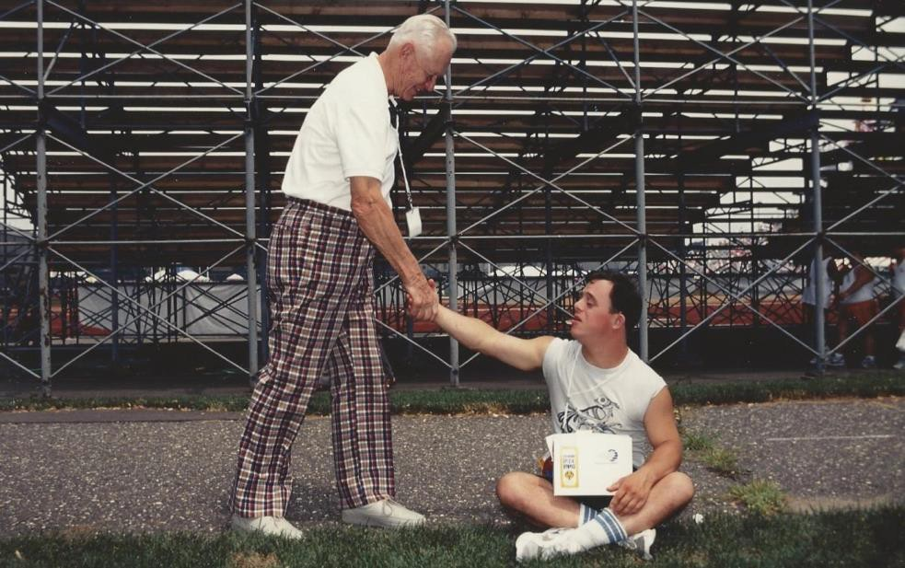
Our goal this year is to raise $110,000 that will go straight to helping Special Olympics Georgia’s 18,646 athletes participate and grow from all we have to offer as an organization.

Sponsorship will help raise monies that will directly offset more than
$1,019,445 in expenses associated with Special Olympics Georgia’s State Games and other athlete programs including lodging, meals, travel expenses and more.

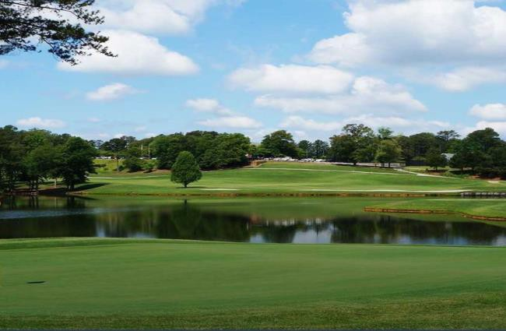

Platinum Sponsor $7,000
Three, Four Player Teams, Three Hole Recognition Signs, Listing on Sponsor Board & website, Recognition at Reception, and 2 Banners
Gold Sponsor $5,000
Two, Four Player Teams, Two Hole Recognition Signs, Listing on Sponsor board and 1 Banner
BOB BUSSE MEMORIAL GOLF CLASSIC

Sponsorship Opportunities
Monday, November 11, 2024

Presenting Sponsor $10,000
Five, Four Player Teams, Four Hole Recognition Signs,
Listing on Sponsor Board & website, Recognition at Reception, Opportunity to speak at Reception, Logo on event PR & flyers, & Opportunity to put logo or company items in Golfer bags and 3 banners.

Golf Cart Sponsor (Only 1 available) $2,350
One, Four Player Team
One Hole Recognition Signs, Literature in Golfer bags or on Golf Carts, Listing on Sponsor Board

Each golfer will receive:

Breakfast Sponsor $3,000 One, Four Player Team Two Hole Recognition Signs, Opportunity to
speak- Golf sendoff, Listing on Sponsor Board, 1 Banner
Silver Sponsor $2,500 One, Four Player Team One Hole Recognition Sign Listing on Sponsor Board
Bronze Sponsor $2,200 One, Four Player Teams
Hole Sponsor $550
One Hole Recognition Sign
Single Golfer $500
(Will be Paired)
A Tournament Gift Bag Breakfast
Boxed Lunch on course
Beverages throughout the day
Hors d'oeuvres and beverages at the post tournament Reception/Silent Auction

Company/Name Address
City St Zip Handicap
Phone Email

How will your payment be made? (Circle one)
Attn: Mary Thomason
6046 Financial Drive
Norcross, GA 30071
Phone: 770-414-9390 Ext. 1121
Mary.Thomason@specialolympicsga.org

Credit card/Debit card/Check
CC#
Exp CVC Zip Code

