Visual asset: MRP-1433_CarvanaxPPA_2024_PickleballForAll_Event-Promo_8.5x11-final.png
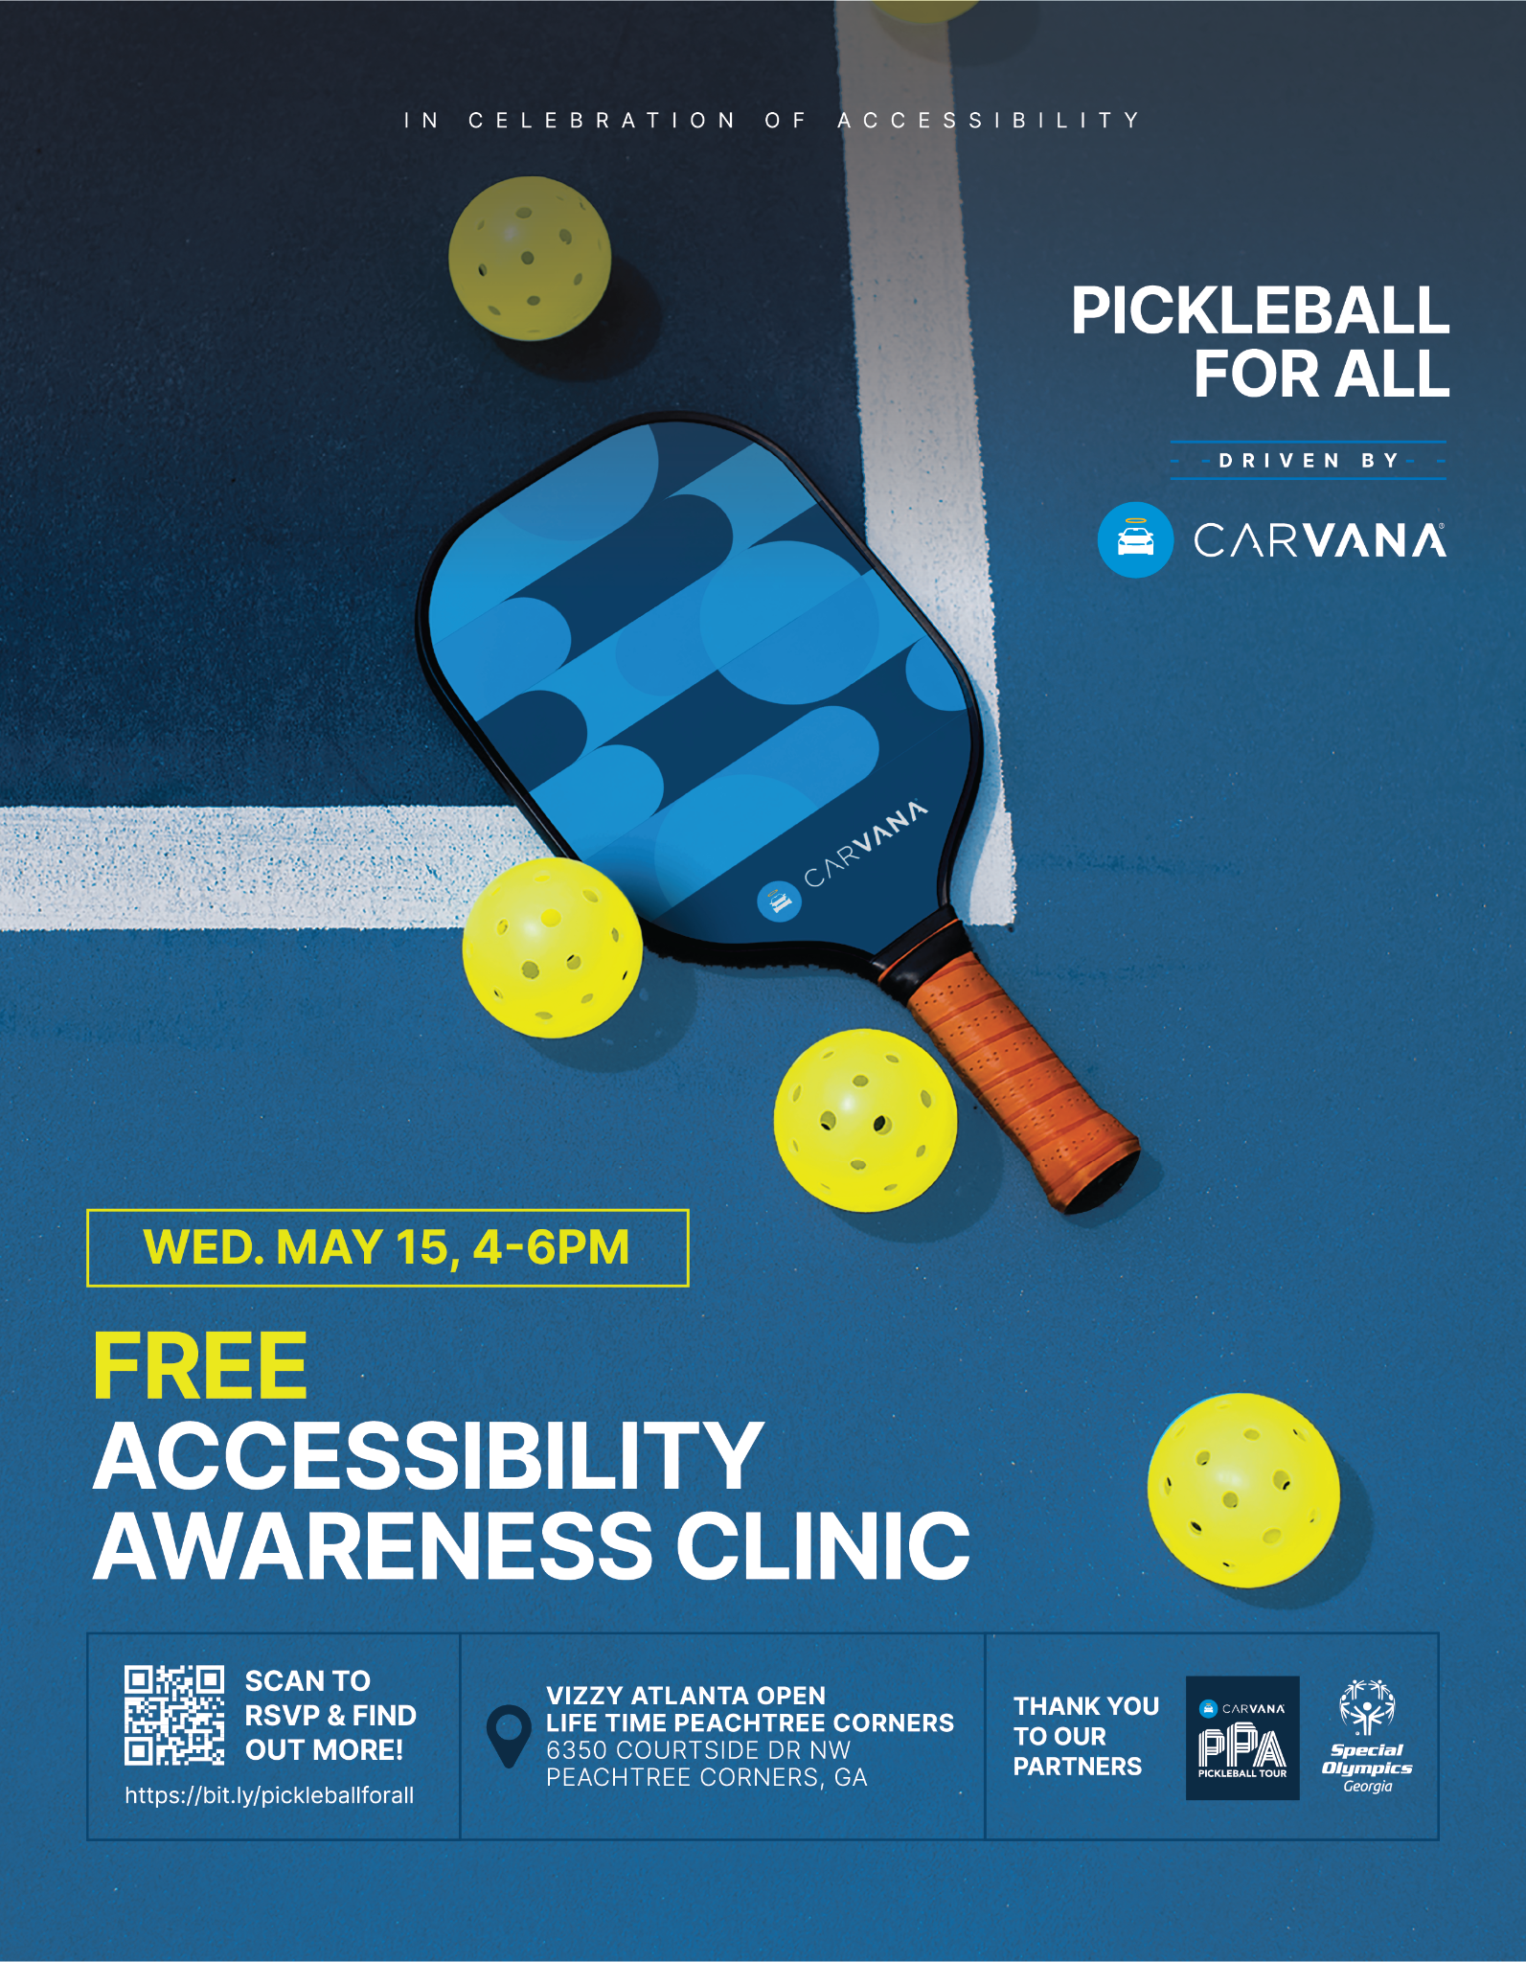

Release timing: May 6, 2024 @ 6 AM PT / 9 PM ET

CARVANA CONTINUES TO CHAMPION ACCESSIBILITY, TEAMS UP WITH SPECIAL OLYMPICS GEORGIA FOR SECOND ANNUAL PICKLEBALL FOR ALL EVENT

In Recognition of Mobility Awareness Month, Carvana and PPA Tour to Host Pickleball Clinic on May 15 in Atlanta

PHOENIX (May 6, 2024) – Following the success of last year’s events, Carvana, an industry pioneer for buying and selling used cars online, is celebrating Mobility Awareness Month with its second annual Pickleball for All event – an accessible pickleball exhibition and clinic for athletes of all abilities. Alongside the Professional Pickleball Association (PPA), the event aims to lower the barrier of entry to the sport of pickleball for the millions of Americans who live with physical or cognitive limitations.

Adding a new dimension to the initiative this year, Carvana is partnering with Special Olympics Georgia (SOGA) to champion local Atlantans with intellectual disabilities and provide them with equipment to help ensure their ongoing inclusion in the sport of pickleball. Sports have always been a force for unification and pickleball is a great example of a sport centered on community, camaraderie and competition that is open to all.

“Special Olympics Georgia is excited to be a part of Pickleball for All at the Vizzy Atlanta Open hosted by the PPA Tour and Carvana,” said Georgia Milton-Sheats, CEO of Special Olympics Georgia. “We appreciate their belief in the organization and our registered athletes. We know our athletes will have an amazing and fun-filled day, while learning more about the sport!”

The event welcomes all ages and skill levels to come play, watch and learn about adaptive pickleball with pros and para-athletes alike. Participants will hear from pickleball para-athletes and able-bodied pros including former Motocross athlete and spinal cord injury survivor, Taylor Nichols, and the No. 1 ranked pickleball player in the world, Anna Leigh Waters.

Attendees will have the opportunity to not only participate in skills clinics and open-play across six courts, but also to cheer on fellow participants. In addition to the excitement of the games, there are chances to win exclusive prizes, including tickets to the Vizzy Atlanta Open, PPA Tour swag and pickleball prize packs. Carvana will also be announcing the donation of two sports wheelchairs to a local organization during the event, keeping with the company’s ethos of providing transparent, accessible mobility for all.

"We’re proud to bring another 'Pickleball for All' clinic to life at the Vizzy Atlanta Open," said Ryan Keeton, Carvana Co-Founder and Chief Brand Officer. “With Carvana's core value of 'there are no sidelines' at heart, alongside the PPA Tour, we're dedicated to breaking down barriers and making sports like pickleball fun and inclusive for everyone.”

The clinic and exhibition will take place on May 15, 2024 from 4:00 p.m - 6 p.m. EST at Life Time Peachtree Corners, located at 6350 Courtside Dr NW Peachtree Corners, Georgia 30092. The event comes in the midst of the Carvana PPA Tour’s Atlanta Slam where professional pickleball players are hitting the courts leading up to the championship tournament on May 19, 2024. Learn more about the Pickleball For All clinic here.

###

About Carvana
Carvana’s mission is to change the way people buy and sell cars. Over the past decade, Carvana has revolutionized automotive retail and delighted millions of customers with an offering that is fun, fast, and fair. With Carvana, customers can choose from tens of thousands of vehicles, get financing, trade-in, and complete a purchase entirely online with the convenience of home delivery or local pick up in over 300 U.S. markets. Carvana’s vertically integrated platform is powered by its passionate team, unique national infrastructure, and purpose-built technology. Carvana is a Fortune 500 company and is proud to be recognized by Forbes as one of America’s Best Employers.

For more information, please visit www.carvana.com.

About Carvana PPA Tour
The Carvana PPA Tour is the professional tour of pickleball, organizing events and rankings for the top male and female pickleball players worldwide and awarding more than $5.5 million in annual prize money with equal play and pay. The Carvana PPA Tour is set to host 25 events in 2023 at world-class facilities like the Lindner Family Tennis Center in Cincinnati, Mission Hills Country Club in California, and the Darling Tennis Center and Mandalay Bay in Las Vegas. Inviting all to compete and "play where the pros play," the Carvana PPA Tour offers amateur divisions of play for every level, unparalleled experiences for fans and spectators, gorgeous venues, pro player meet-and-greets, food/beverages, live entertainment, VIP upgrades, giveaways and games, shopping, vendors, and more. Founded in 2018 and based in Salt Lake City, the Carvana PPA Tour is owned and operated by parent corporation, Pickleball.com. For more information, go to www.ppatour.com. See Pro Player Profiles and follow us on social: Twitter, Instagram, YouTube, Facebook and LinkedIn.

About Special Olympics Georgia (SOGA)
SOGA provides year-round sports training and athletic competition in a variety of Olympic-type sports for 18,546 children and adults with intellectual disabilities, giving them continuing opportunities to develop physical fitness, demonstrate courage, experience joy, and participate in the sharing of gifts, skills, and friendships with their families, other Special Olympics athletes, and the community. For more information, visit www.SpecialOlympicsGa.org.
MEDIA CONTACT:
Carvana Communications
press@carvana.com

